# IST769 Homework Submission Template

## Basic Information

Your Name: STEPHEN OMONDI  
Your SUID: 943934046  
Your Email: SOOMONDI@SYR.EDU  
Date Due: Wednesday, October 09, 2019  
Homework #: LABWORK 1

## Instructions

For each answer, please include your answer as text, and any screenshot(s) which demonstrate your answer was executed. Most importantly, make sure to include evidence your answer is correct. This will most likely be a screenshot. If you had issues, problems, or had to make assumptions include them in your answer.

## Your Answers:

1. 1. **What would be the command to bring up the redis environment? How is the command different from the mssql environment? How is it the same?**

cd .\redis\

docker-compose up -d

docker-compose exec redis redis-cli

It is different from the mssql environment because these commands are called inside the *redis* directory – not *mssql* directory. Also, they differ in how the client is called, redis client is called with *docker-compose exec redis redis-cli*. However, the same command structure is used in both cases – once inside the specific folder/directory to start the environments.

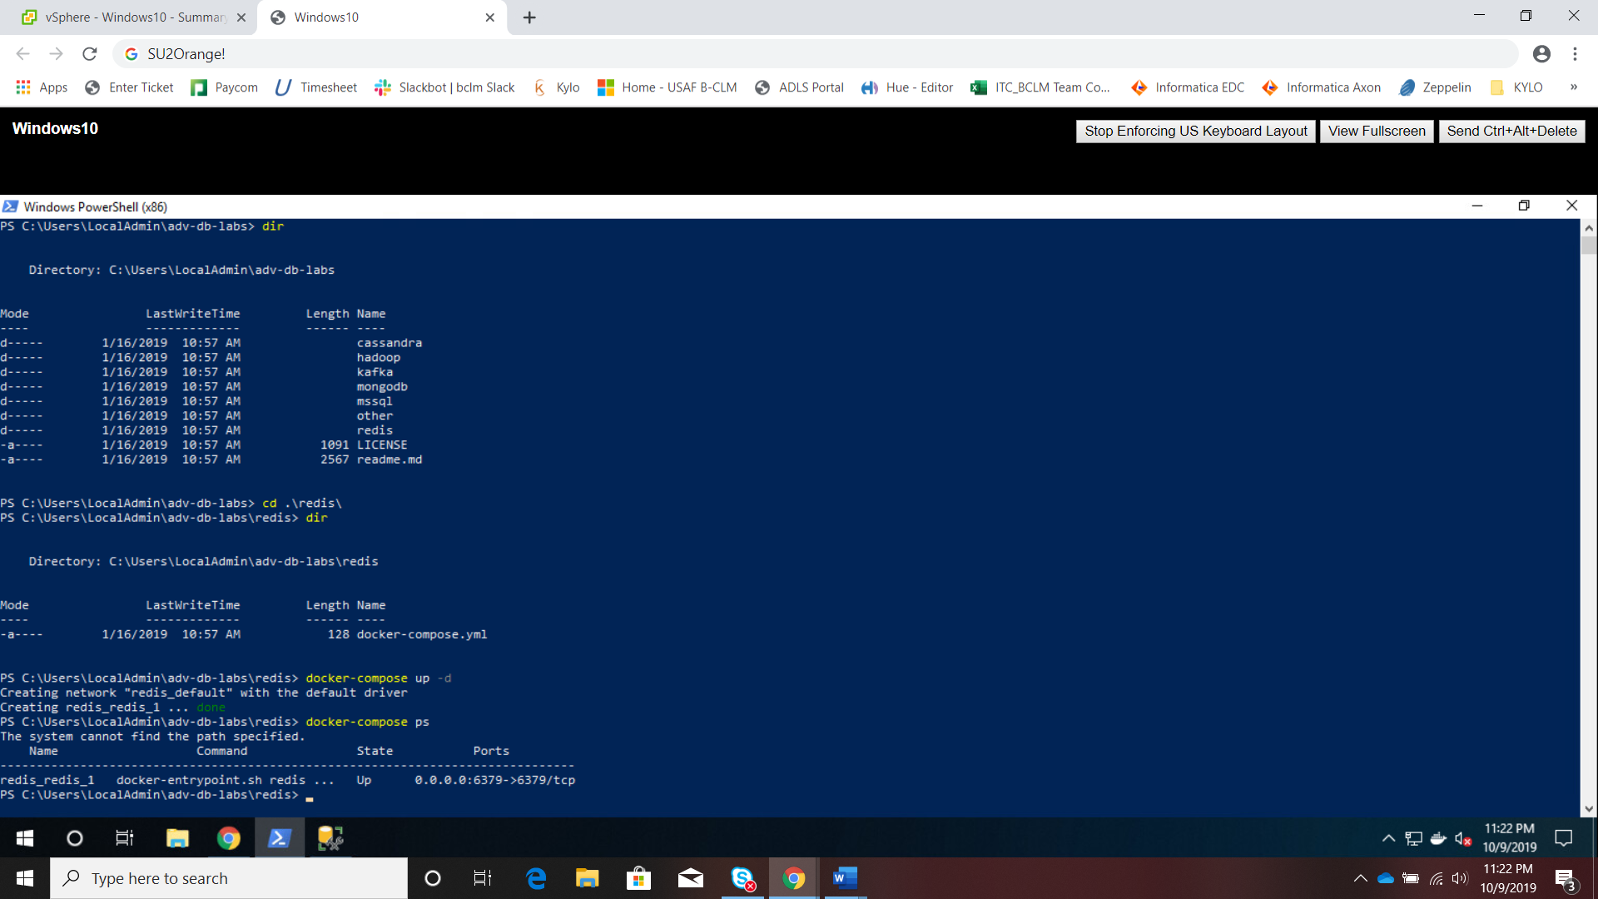

1. **Where is the specific configuration information about each environment stored?**

It is stored in the *docker-compose.yml* file found in each directory/environment.

1. **Explain the difference between stopping an environment and bringing it down. Elaborate with use-cases for each.**

Stopping the environment terminates the current service instance that are running but does not lose the objects created thus far. Bringing the environment down removes all objects created during the session of the running environment – it resets the whole environment as if no objects were ever created.

1. **What happens when you bring up an environment that is already up?**

You receive a notification that the environment is already up-to-date:

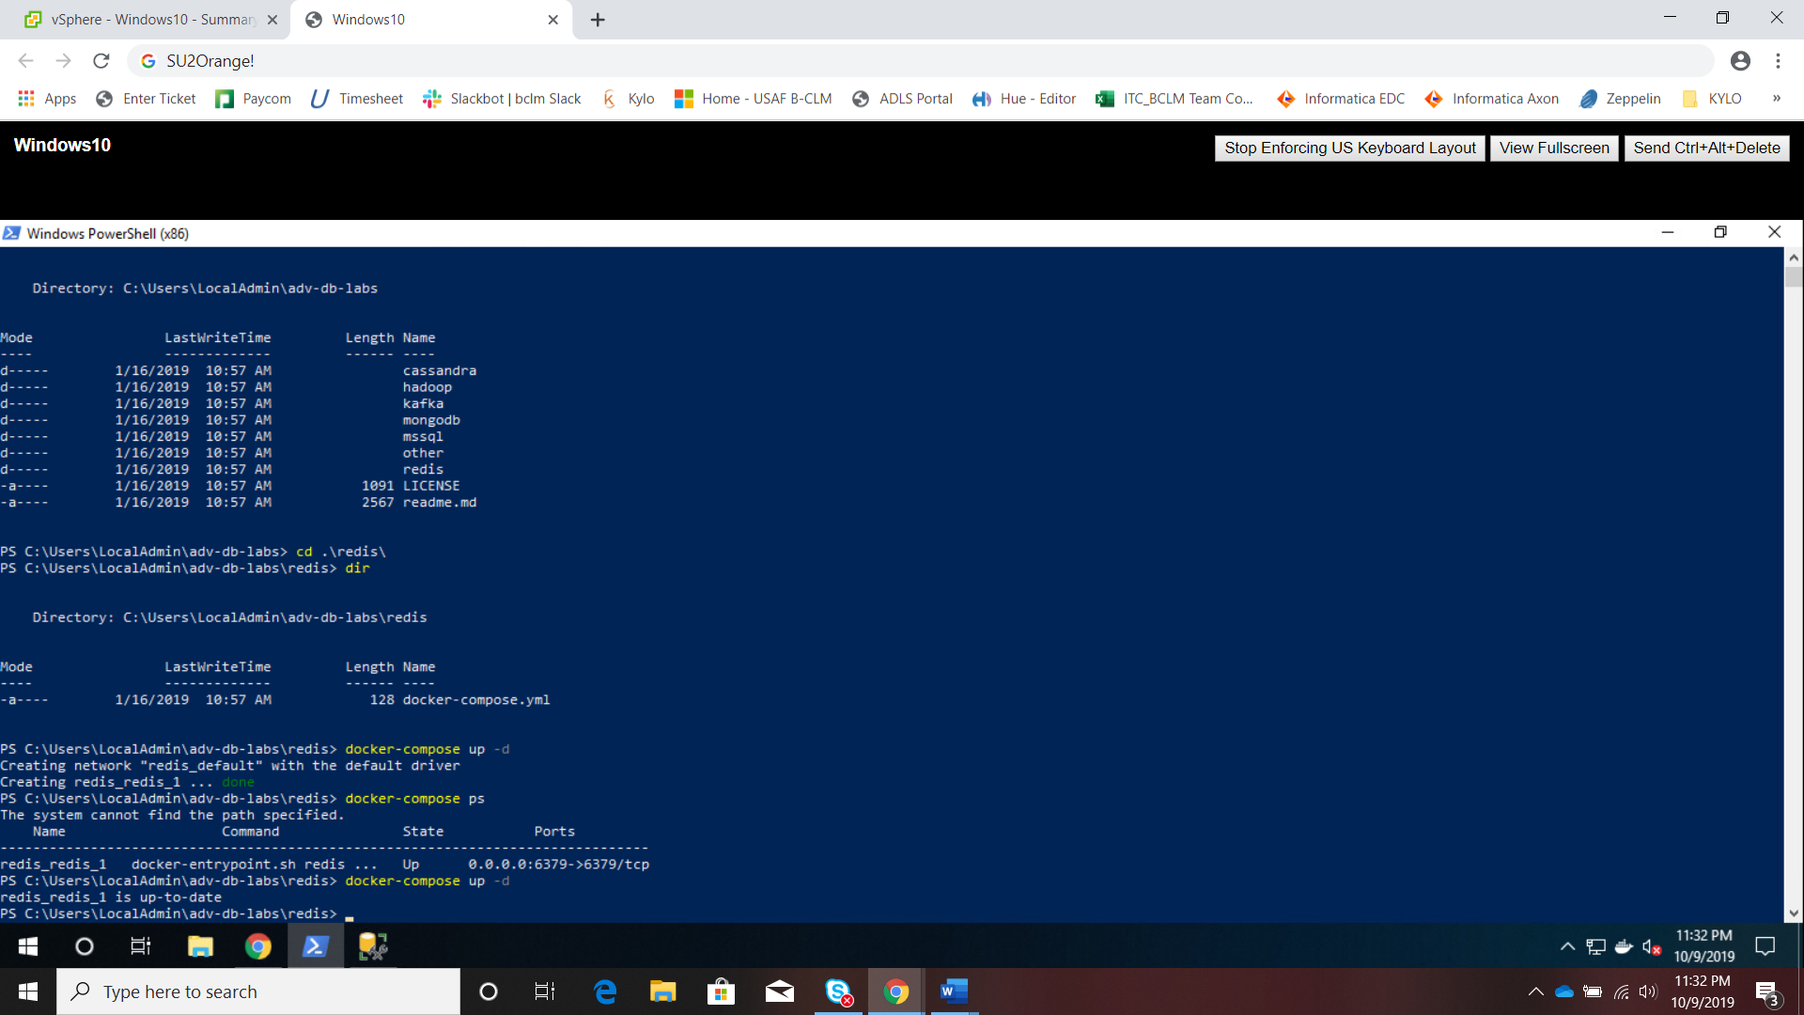

1. **What was the most difficult aspect of this lab? What changes could be made to make it less difficult?**

Accessing the vlab was a little cumbersome, But I feel that is only true because this is a new routine. With practice, it shouldn’t be hard.